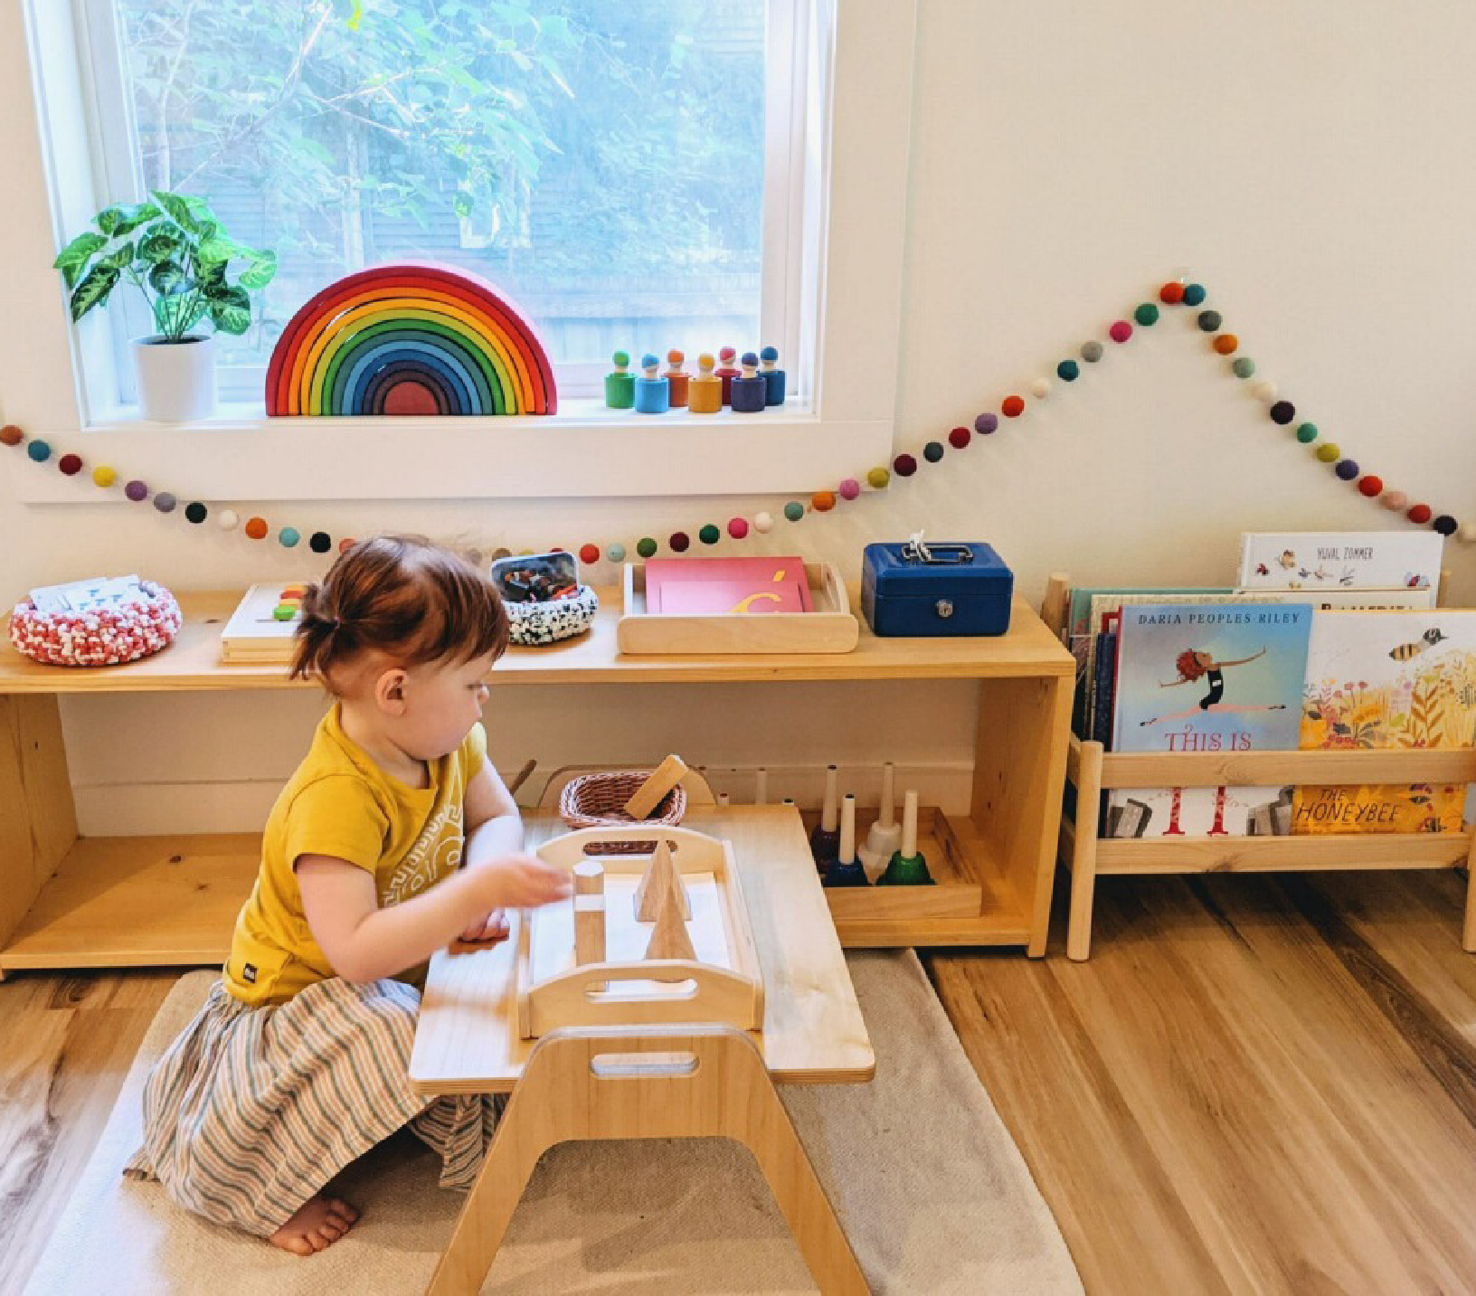
The Montessori Guide

10 Steps to Encourage Independent Play

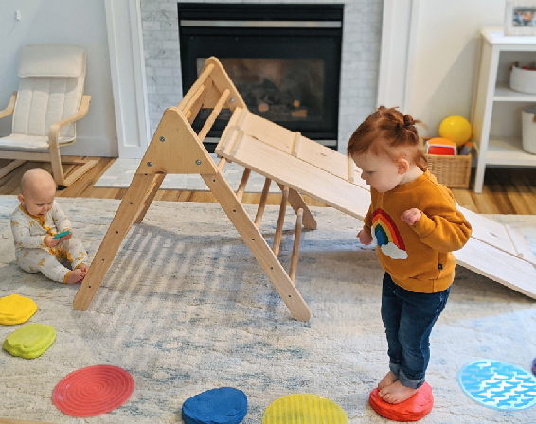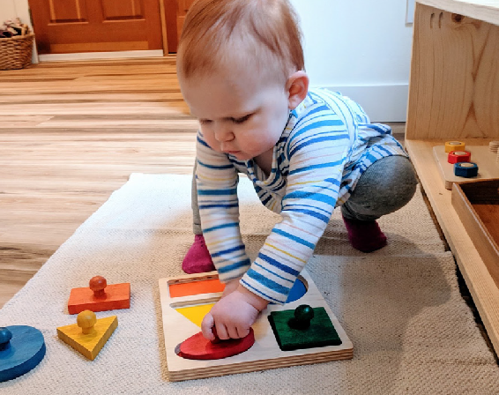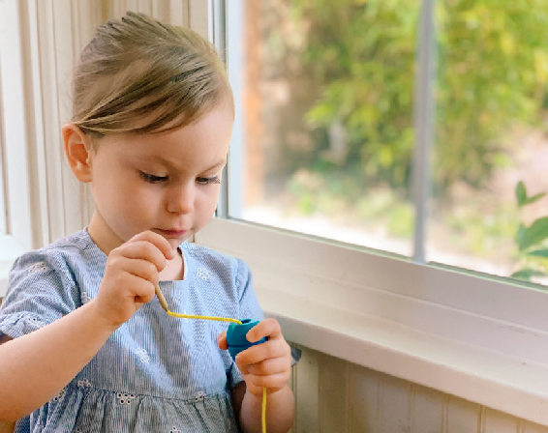HOW TO ENCOURAGE YOUR CHILD TO PLAY INDEPENDENTLY, FOR LONGER
Play is the work of the child. Through play, children learn, create, take chances, make mistakes, and try again. Through independent play, children develop self-confidence, concentration, and the ability to find joy in their own accomplishments. Yet sometimes it seems near impos- sible for our child to play without us, the parents, being a constant source of entertainment.

01

MAKE IT A PART OF THE ROUTINE
Independent play is a skill, and skills require consistency and practice. The simplest way to be consistent about play is to build it into your daily routine. Pick a time or two during the day when the only expectation is to play. This is a time when we are available and in close proximity but not playing with them or for them.
02

START SMALL
It’s best to start small if independent play is new for our child. Start with just 5 to 10 min- utes of independent play. It can help to find a task for ourself, such as folding laundry. This allows us to supervise while not being immediately available. A visual timer can be helpful for children three and older. We can gradually increase the independent play time as they get used to this routine.

03

FIND THE BEST TIME OF THE DAY
When we are choosing your designated “independent play” time(s) for the day, we need to consider our child’s general mood at different times of day. Are they more focused in the morning after breakfast? Do they get a second wind of energy after lunch? Often the best times for independent play hap- pen after meals, after outdoor play, and after

04

MAKE SURE YOU’VE SPENT TIME
TOGETHER
Children crave connection. We want to make sure we have spent quality time with them prior to stepping away and asking them to play on their own. Just as we can set times for indepen- dent play, set other times for connection. This could be 10 minutes or 30 minutes, but it’s a time (without screens) to spend together. Connection time could be reading books, playing, baking, taking a walk, or any other activity spent together.

05

PLAY WITH, NOT FOR THEM
The way we play with our child can even have an effect on how or if they play independently. For example, if we are playing for them, we might be creating or accomplishing something they aren’t able to replicate themselves. If they feel that they can’t play “as well” as us, they are less motivated to create on their own. Let them take the lead in play. If they can get prac- tice coming up with ideas and problem solving with us present, it’ll be easier for them to do so

06

LIMIT DISTRACTIONS
Just as we want our together time to be free of distractions, independent play should be too. Avoid having the TV on in the background and be aware of other loud noises happening that could break their focus. We can experiment with having background music, as some are sen- sitive to any noise and others enjoy it.

07

PLAY SPACE
One way to minimize distractions and encourage independent play is to set up a designated play space. This does not need to be its own room, but could be one small section of the house. For babies and young toddlers, it is often easiest to set this up in the living space where you can keep an eye on them at all times. For preschoolers and older, a playroom might make more sense, where they have a space to call their own.

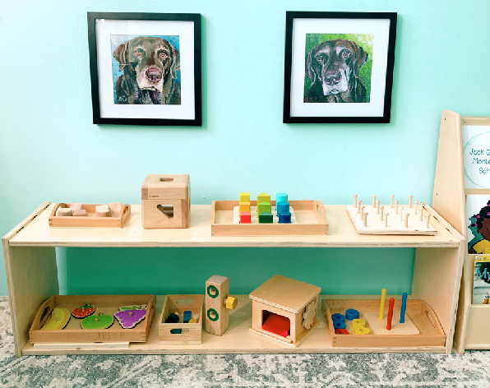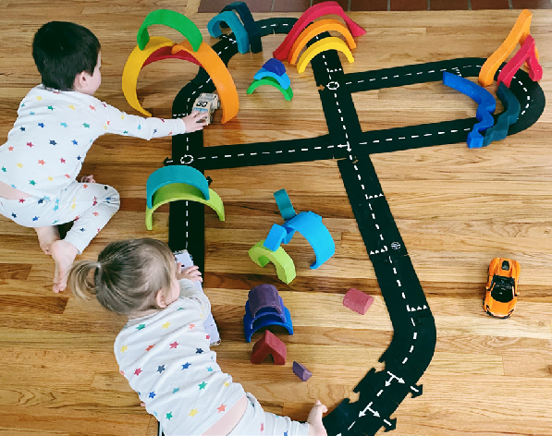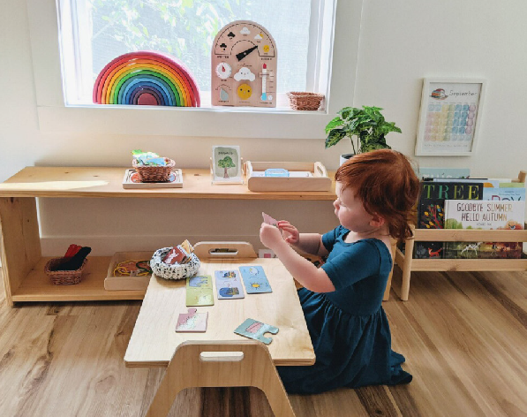08

ORDER
Wherever we set up a play space, it’s import- ant to keep in mind that children play best when their environment has order. Too many toys can be overwhelming and lead to less play. We aim to have every toy that is avail- able visible to our child rather than piled in bins, which can lead to dumping and throw- ing rather than play. When we rotate toys in and out, old toys become new again, leading

09

TYPES OF MATERIALS
Certain types of toys or materials may hold your child’s attention longer than others. Suggestions include open-ended toys (e.g. blocks or vehicles), sensory play (e.g. play dough), toys that encourage repetition (e.g. ball tracker), practical life (e.g scrubbing the table), and toys that they may have mas- tered but still enjoy. These materials ideally require little to no help, and do not create a giant mess that requires our intervention (e.g.

10

VALUING PROCESS OVER PRODUCT
A primary reason the toys listed above are especially inviting for a young child to play with independently is that they can focus on enjoying the process rather than getting it “right” or the product itself. If we over-cor- rect our child when they are playing or work- ing, they feel frustrated and less confident in their own ability. The more we can value our child’s play as what it is, the more confident they feel, and the more likely they will want to play independently.

Learn more about using Montessori at Home

The Montessori Guide: A month-by-month guide, with each month’s guide includ- ing six suggestions for Montessori materials and activities based on your child’s age (0 to 3 year). All of the monthly guide’s suggested activities are aimed at encouraging your child’s fine motor, gross motor, language, and practical life skills.
A Complete Guide to a Montessori Kitchen: We know that starting Mon- tessori at home, especially in the kitchen, can be intimidating, so we hope we can break it down into simple steps for you. This guide includes helpful tips for babies as young as 6 months and children as old as four and beyond. We include helpful language to use with your child as well as tips for dealing with challenging behavior. It is never too early or too late to incorporate Montessori into your kitchen and dining space, and this is a perfect way to start!
The Recipe Guide: As an extension of our Montessori Kitchen Guide, we are excited to introduce a guide including 10 visual recipes to help your child independently prepare their own food!

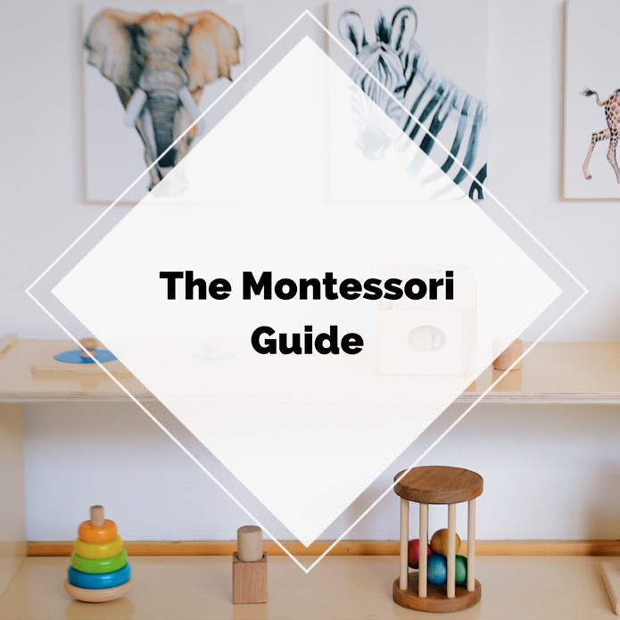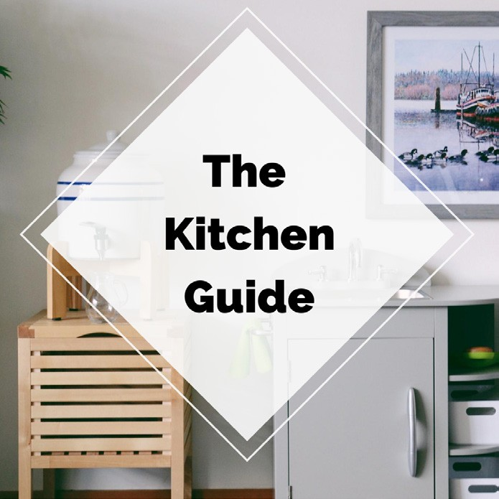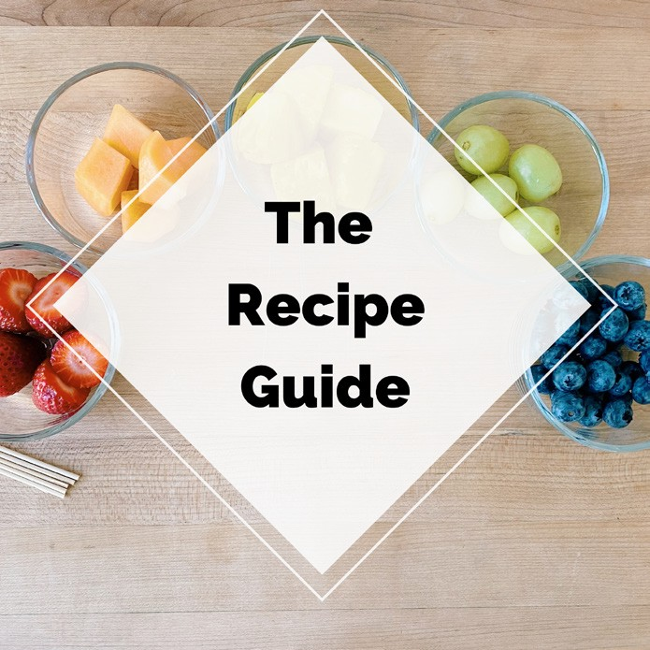Visit links above for more information.

Theresa & Bridget

Montessori
M
in
otion

